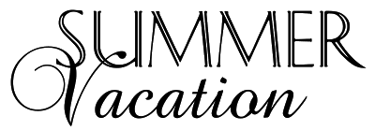



Dear Parents,

I just want to give you this Notice stating when our 3 weeks Vacations for the year of 2025 will be….

1st week February 17-21

2nd week May 19-23

3rd week August 8-15

As a reminder these weeks are Paid. Preschool Center will Reopen

Monday, February 24, 2025

Monday, May 26, 2025

Monday, August 18, 2025

Enjoy the time off!!